How to add a placement onto Unifrog

Once you have found your placement you will need to add it onto unifrog.
All students should have a log in from before – please contact Mrs Lindsay alindsay@st- thomasmore.southend.sch.uk if you have not or got any queries.

Sign In - Unifrog – click on this link and then you should come to the scree below

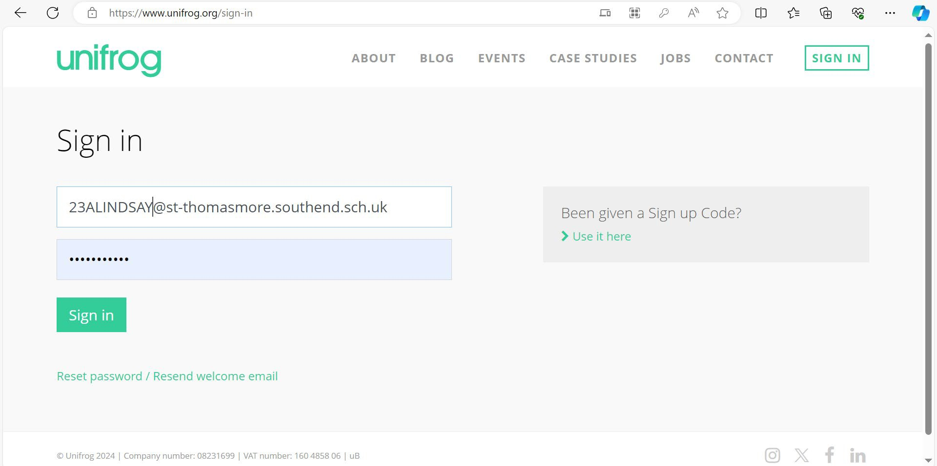If you don’t know your password then click the reset password link and then enter your email and you will be sent a rest email to your school email address.

If you know your school email address put it in the ﬁrst white box and then enter your password
below and CLICK sign in.
Then sign in as normal.
Once you have signed in you will see the page below

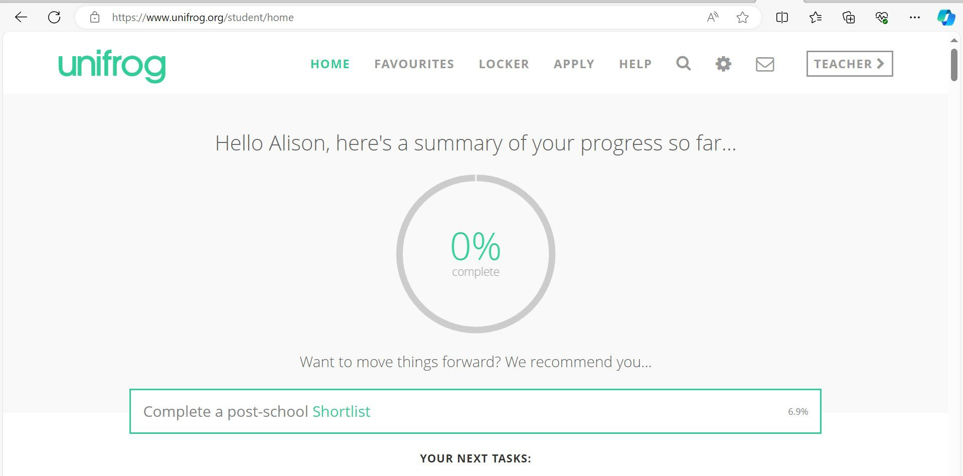

Scroll down until you see a number of coloured boxes like below:

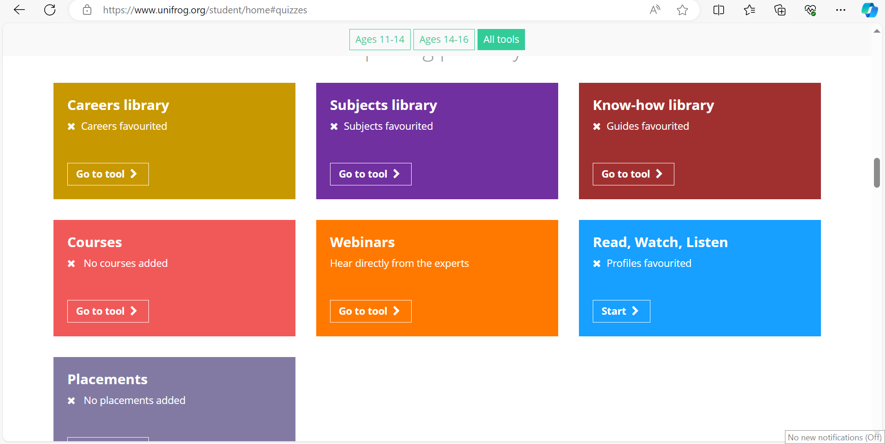
And choose the grey ‘placements tool’

CLICK on ‘ADD A NEW PLACEMENT’
Choose ‘in person’ placement
Then you will add all of the following information:
- In person or virtual – IN PERSON
- Placement co-ordinator – MRS LINDSAY/MRS BRADLEY

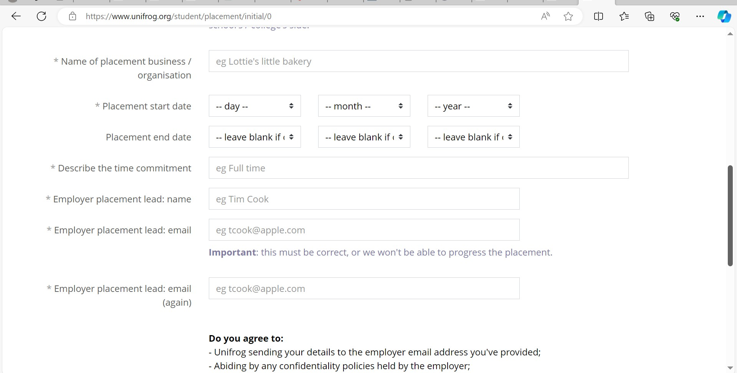

Name of Business/organisation Placement start date – 28th June 2027
Placement end date – 2nd July 2027
Describe the time commitment – FULL TIME
Employer lead name: ENTER THE PERSONS NAME YOU ARE DEALING WITH
Employer placement lead email: ADD THEIR EMAIL ADDRESS Employer placement lead email AGAIN: ADD THEIR EMAIL ADDRESS
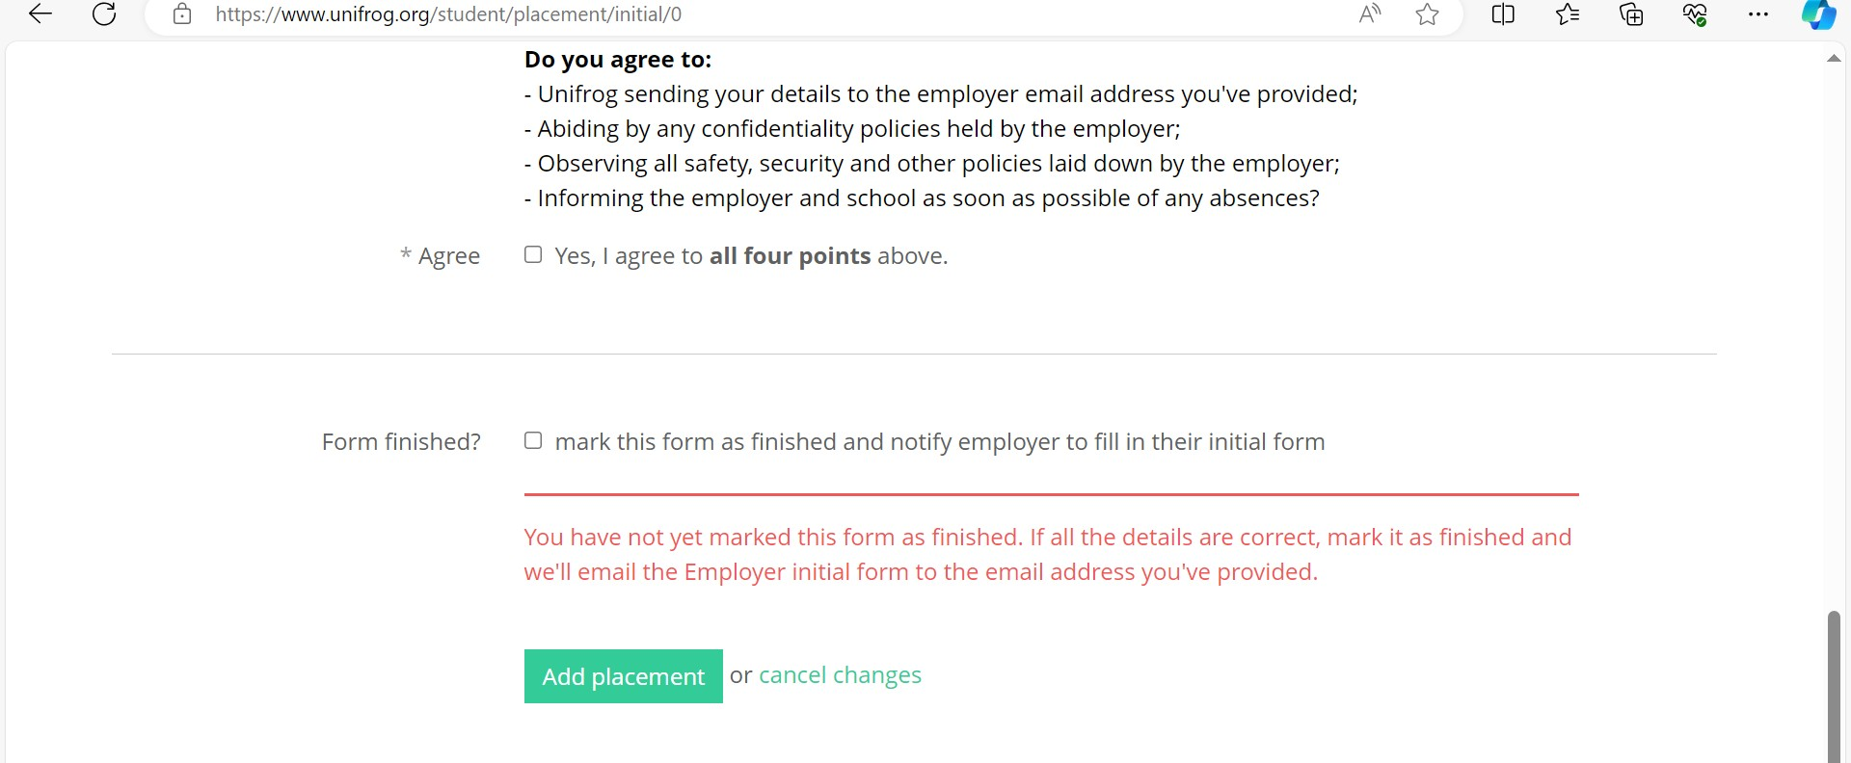
Click agree
and form ﬁnished and then CLICK ADD PLACEMENT

This will then email the employer to ask for public liability insurance and other documents for them to upload, once that is complete it will be returned to the school to say all information is current and correct and SENT to parents for ﬁnal sign oﬀ and the RETURNED to school ready to go.

